You are receiving this email as a member of the media.
If you wish to unsubscribe from future messages, please reply with UNSUBSCRIBE in the subject line.

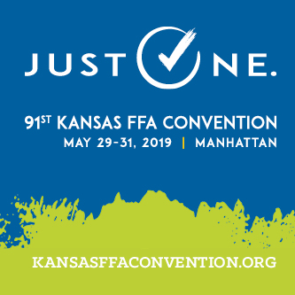 | NEWS RELEASE  Kansas FFA Association  Website: www.ksffa.org  Facebook: facebook.com/ksffa  Twitter: @KansasFFA | Hashtag: #ksffa  Blog: kansasffaconvention.org  Flickr: flickr.com/ksffa | Instagram: @ksffa  For more information, contact:  Andrew Strasburg  620-636-0333, media@ksffa.org
FOR IMMEDIATE RELEASE
May 29, 2019

(Chapter Name) FFA Members Attend Kansas FFA State Convention in Manhattan

MANHATTAN, Kan. – Members from the [FFA Chapter Name] FFA chapter attended the 91st Kansas FFA Convention held May 29–31, 2019. The convention is one of the largest annual gatherings of Kansas high school students as more than 1,900 FFA members, agricultural educators, and supporters converge at Kansas State University (KSU).

[FFA Chapter Name] FFA members who attended the convention were: [Insert FFA members’ names here]

“The annual Kansas FFA Convention is a three-day celebration of achievements of our 8,954 members and 205 chapters from across Kansas,” said Max Harman, 2018–19 Kansas FFA state president. “This year’s convention features keynotes from former America’s Got Talent contestants and professional bull and bronc riders, leadership workshops, meal packaging for hunger relief, and so much more.”

The opening session of convention convenes in McCain Auditorium. In addition to seven convention sessions highlighting FFA members and keynote addresses, members are able to participate in tours of KSU College of Agriculture departments, compete in Leadership Development Events, attend activities such as the convention concert, opportunity fair, or leadership workshops, and even volunteer to package meals for hunger relief services.

For more information about the 91st Kansas FFA Convention, visit kansasffaconvention.org.

The Kansas FFA Association is a statewide organization of 9,854 agricultural education students in 205 chapters in every corner of Kansas. It is part of the National FFA Organization, a national youth organization of 669,989 student members preparing for leadership and careers in the science, business and technology of agriculture with 8,630 local chapters in all 50 states, Puerto Rico and the Virgin Islands. Our mission is to make a positive difference in the lives of students by developing their potential for premier leadership, personal growth and career success through agricultural education. Visit www.ksffa.org for more information.

###

